begin  
 out 1 .  
end

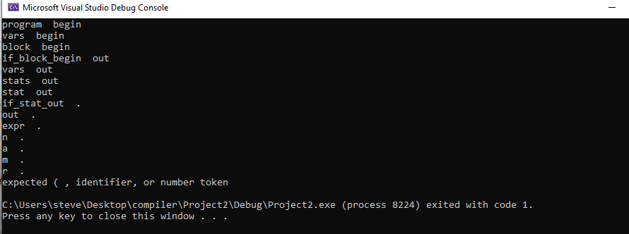

data x = 1 .  
data y = 2 .  
begin  
 out 1 .  
end

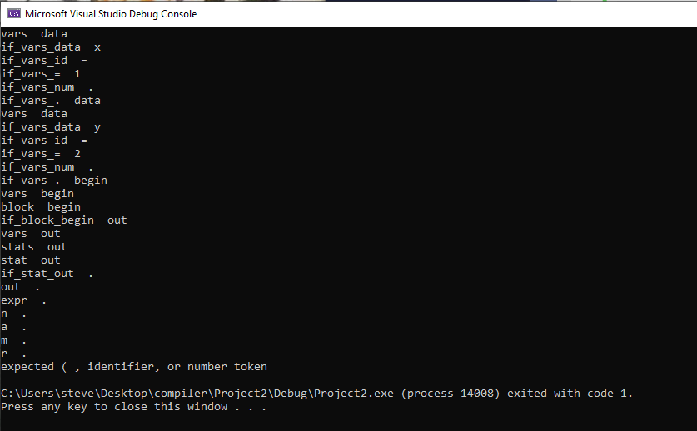

data x = 1 .  
data y = 2 .  
begin  
 data z = 3 .  
 out 1 .  
end

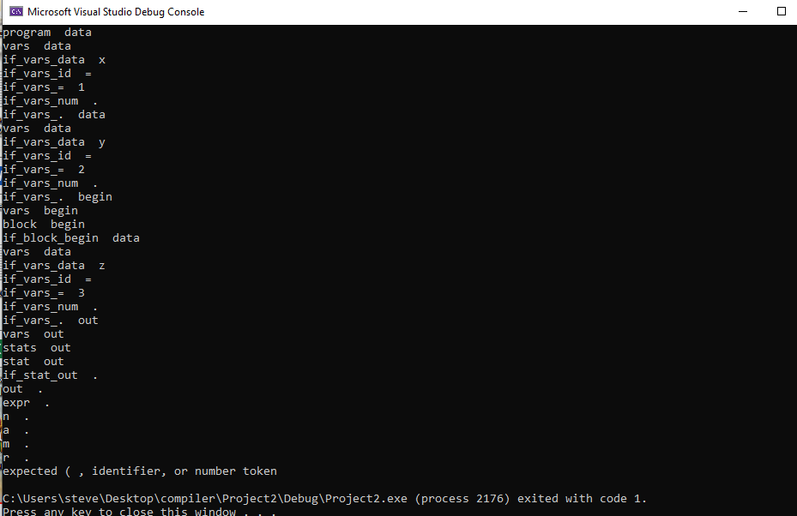

data x = 1 .  
data y = 2 .  
begin  
 data z = 3 .  
 begin   
 out 1 .  
 end   
 out 2 .  
end

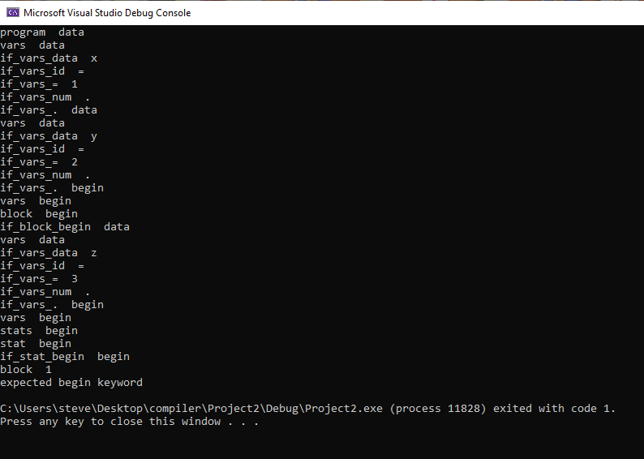

data x = 1 .  
data y = 2 .  
begin  
 in x .  
 out x + 2 / ( 2 - y ) .  
end

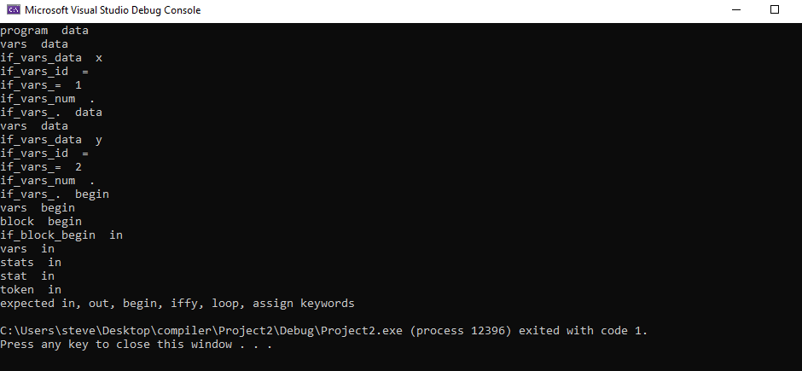

data x = 1 .  
begin  
 in x .  
 iffy [ x < 0 ] then  
 out x . .  
end

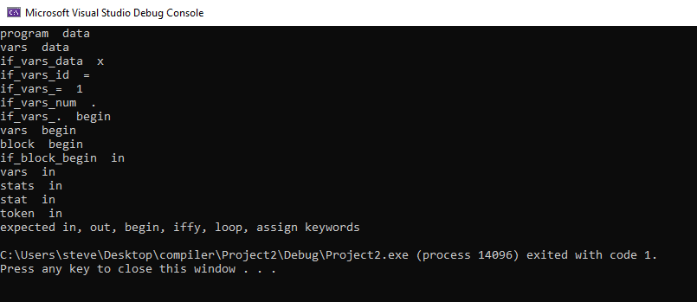

data x = 1 .  
begin  
in x .  
iffy [ x < 0 ] then  
 begin  
 x = 5 .  
 out x .  
 end .  
end

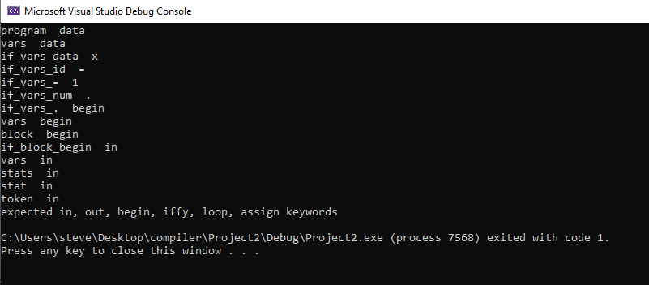

data x = 1 .  
begin  
in x .  
loop [ x < 0 ]  
 out x . .  
end

